We tried to deploy the survey in multiple channels, one of them is using the ANU association platform such as ANUSA, CSSA to distribute the survey to undergraduates. Although, they refused to deploy the survey with acceptable reasons, at least we tried. The content below is the communication with ANUSA and PPM via email.

**Part 1 First Meet**

March 9

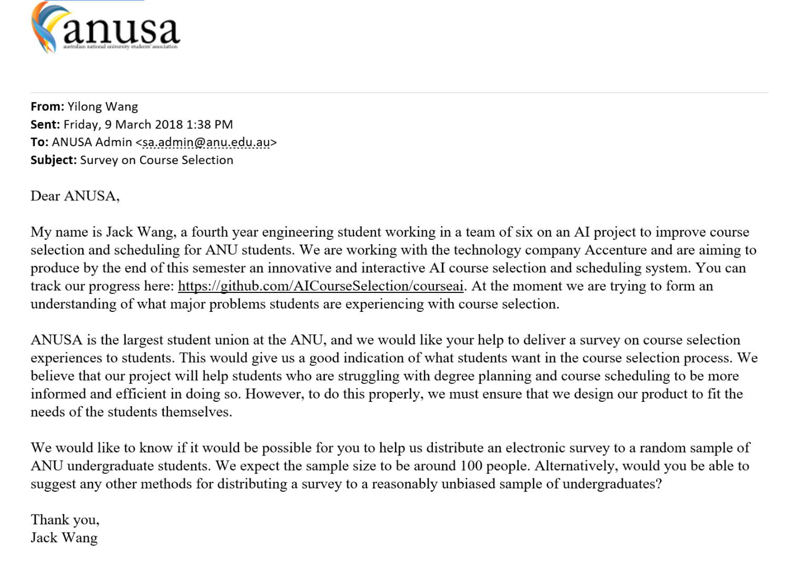

Then, I got the reply from them saying that

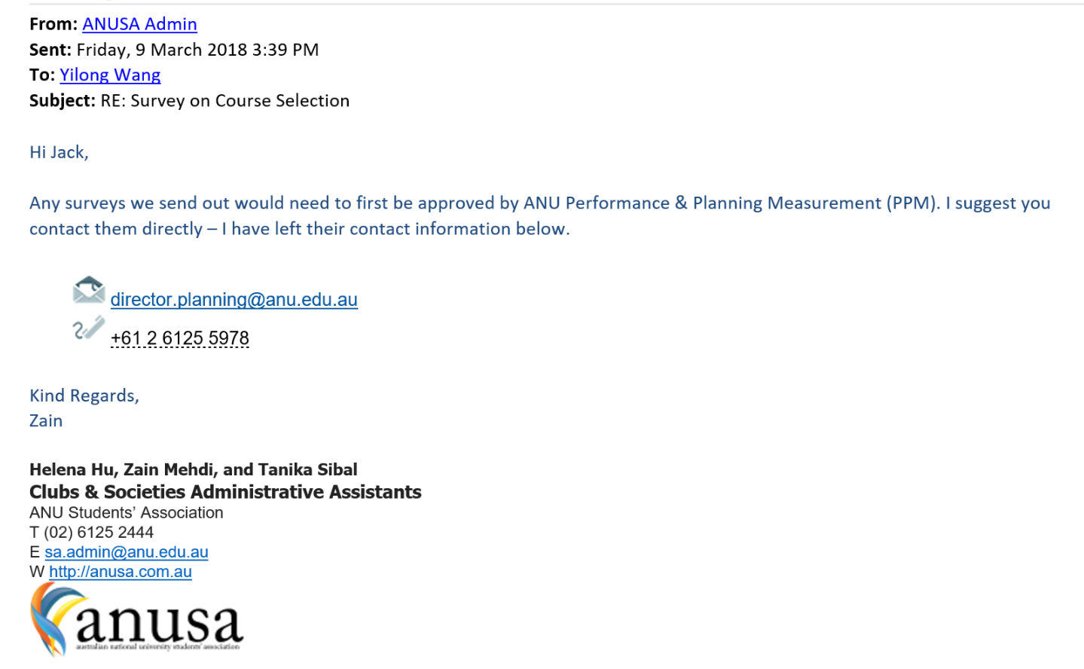

**Part 2 Handover**

March 11

Therefore, I emailed planning and performance measurement team (PPM) with similar content. The director replied me:

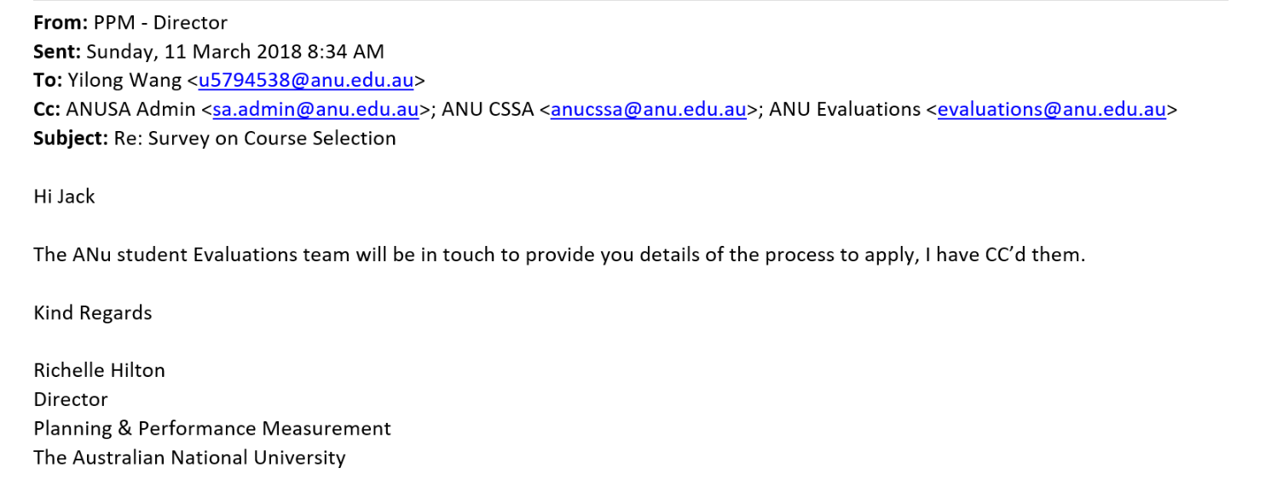

Part 3 handover handover

March 13

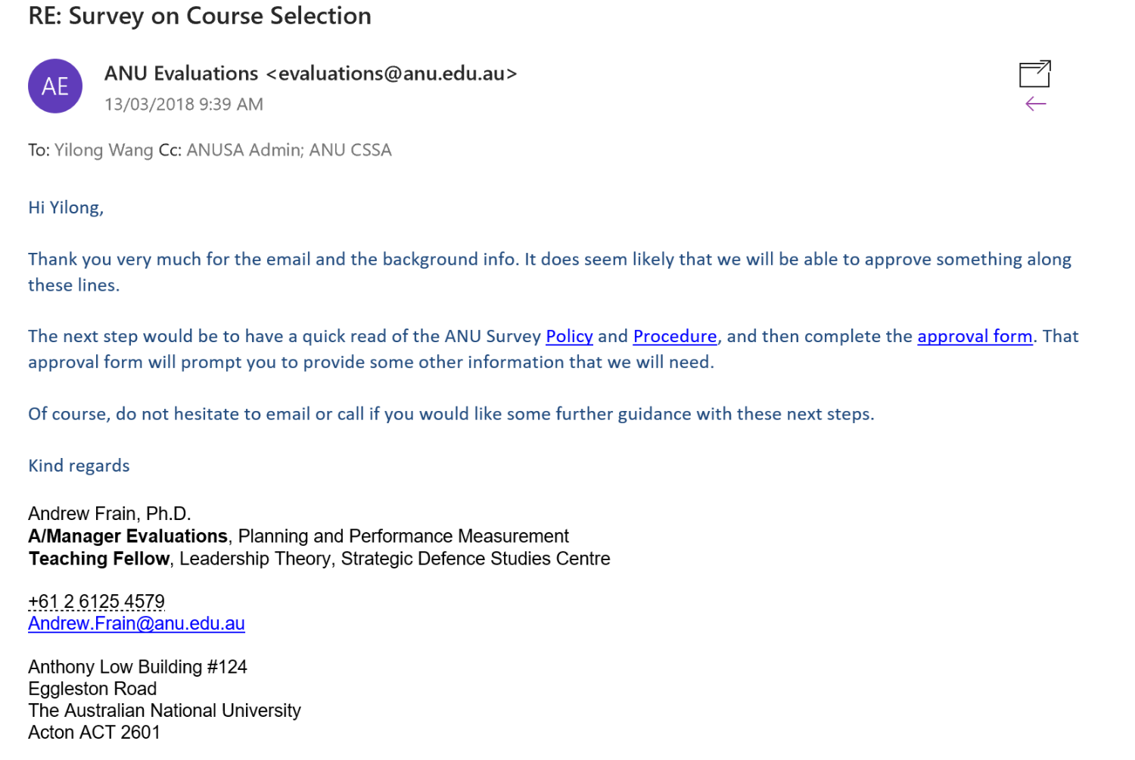

I got the email from ANU evaluation team, and roughly go through the policy and procedure, then I completed the Survey Approval Form. After that, we had more discussion about survey with ANU evaluation director, Andrew Frain.

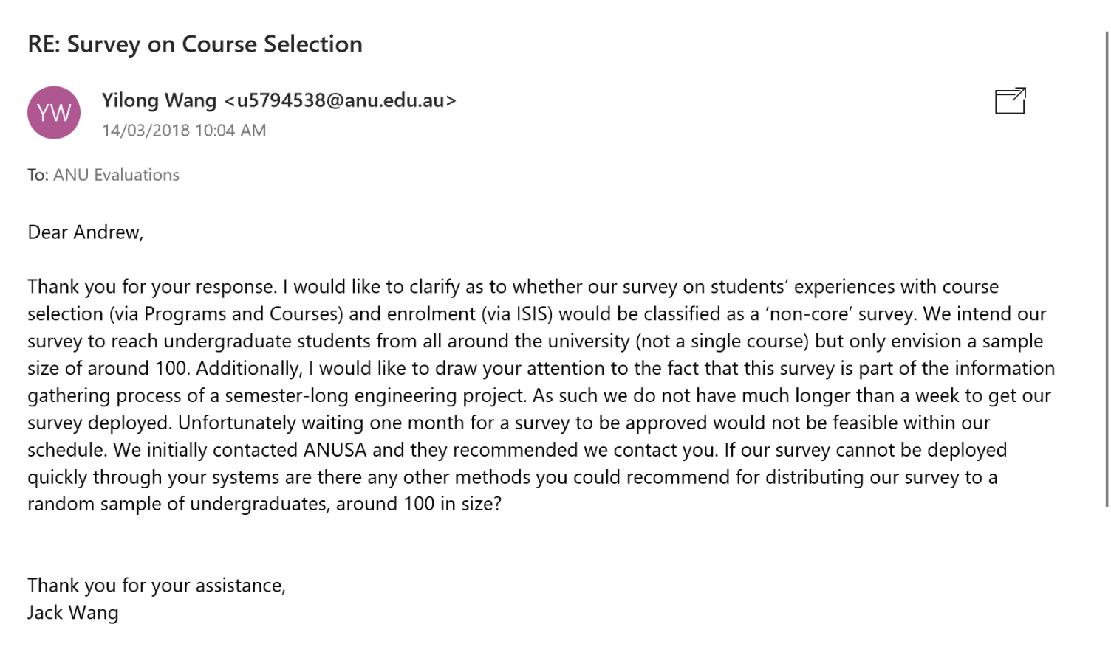

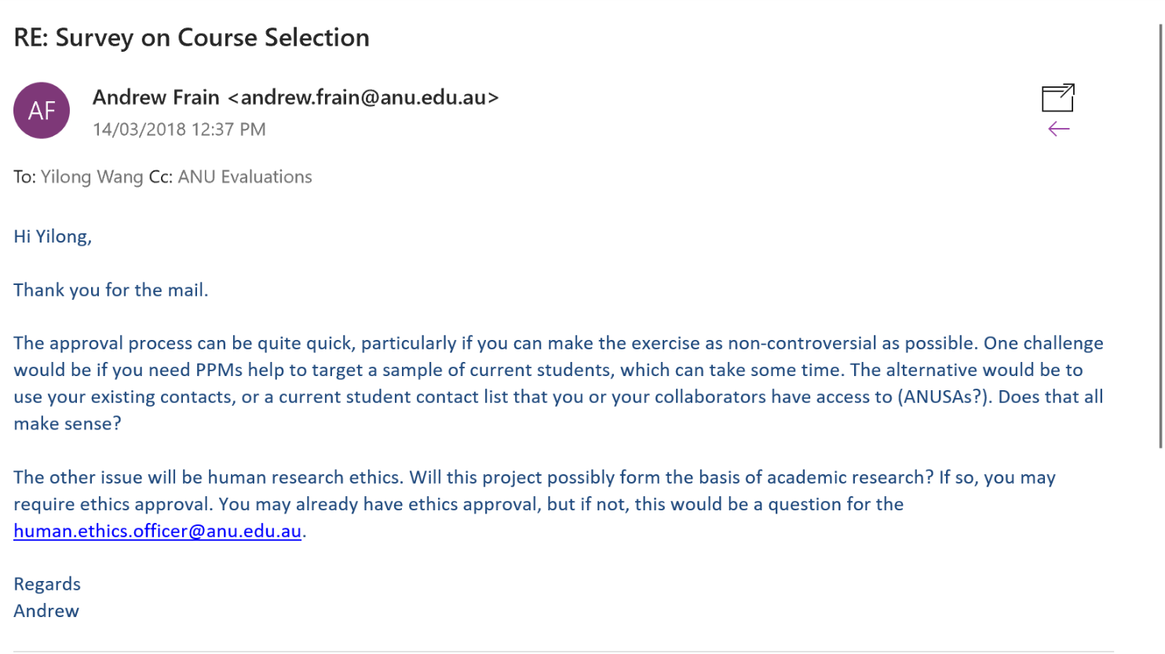

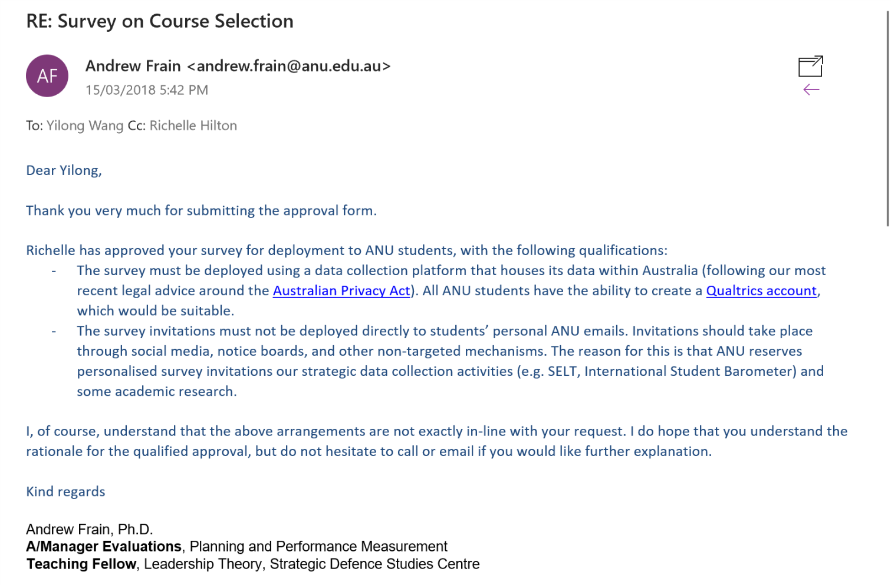

Part 4 End

I thought the survey is approved, however, there are more procedures to go through. Then, I got the email from ANUSA saying that they are unable to deploy the survey. They indeed made some useful suggestions for us to deploy the survey in other channels.

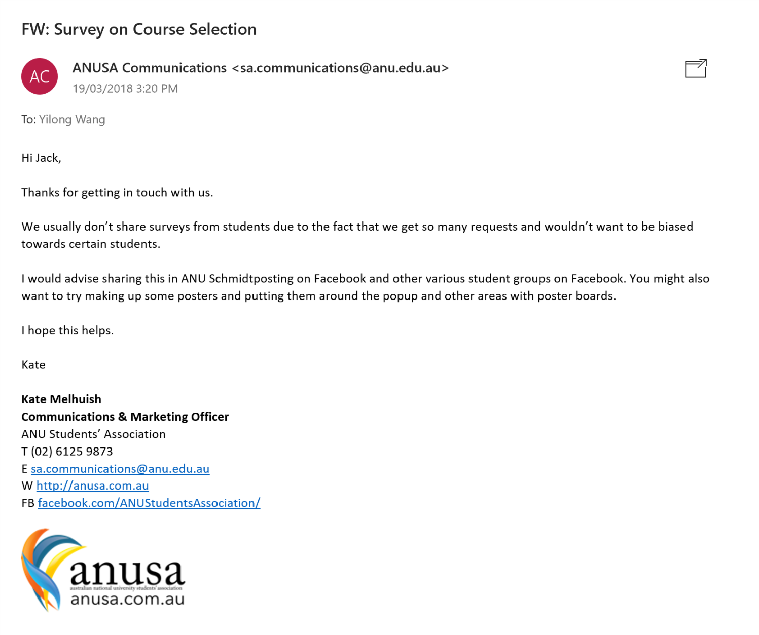

Although, we failed to deploy the survey from ANUSA, as I said above, at least we tried.